Assignment -4

Docker and Kubernetes

|  |  |
| --- | --- |
| Assignment Date | 21 October 2022 |
| Team ID | PNT2022TMID53909 |
| Student Name | Sunil Raja A |
| Student Roll Number | 95071912100 |
| Maximum Marks | 2 Marks |

1. **Pull an image from docker hub and run it in docker Playground**

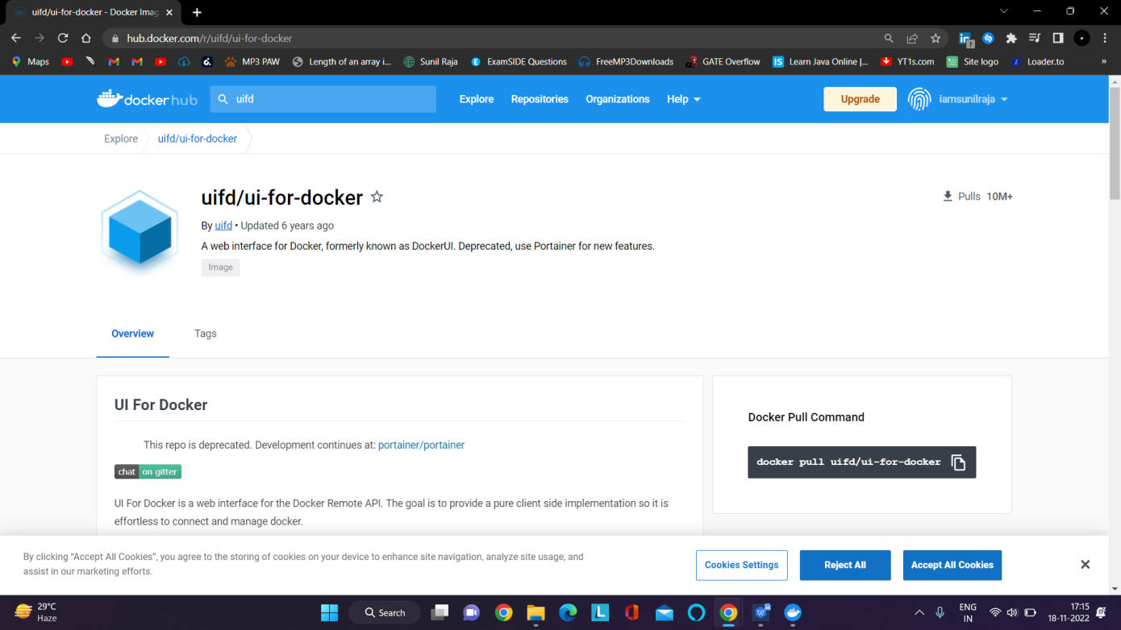

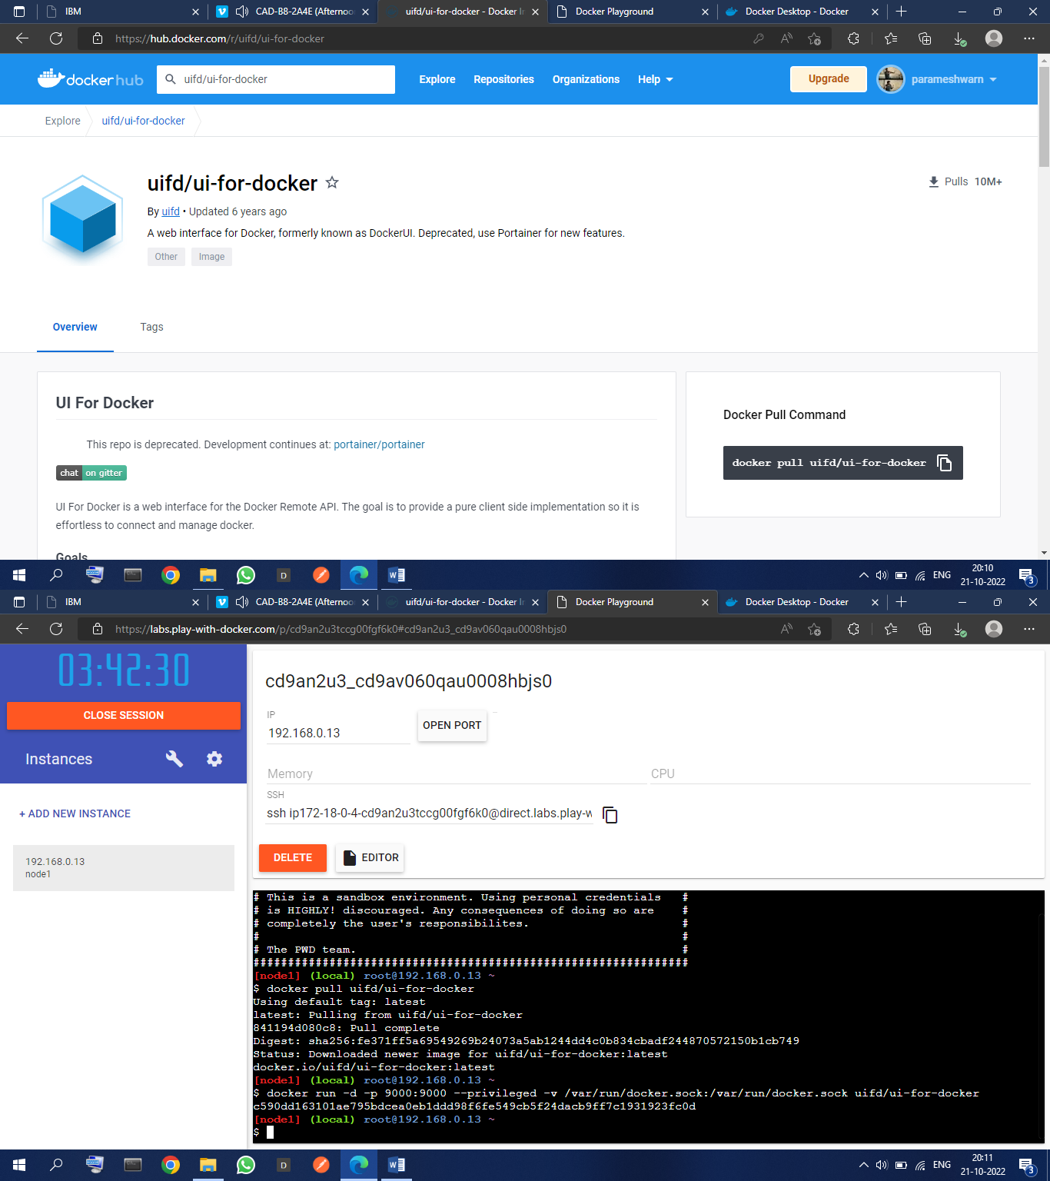

1. 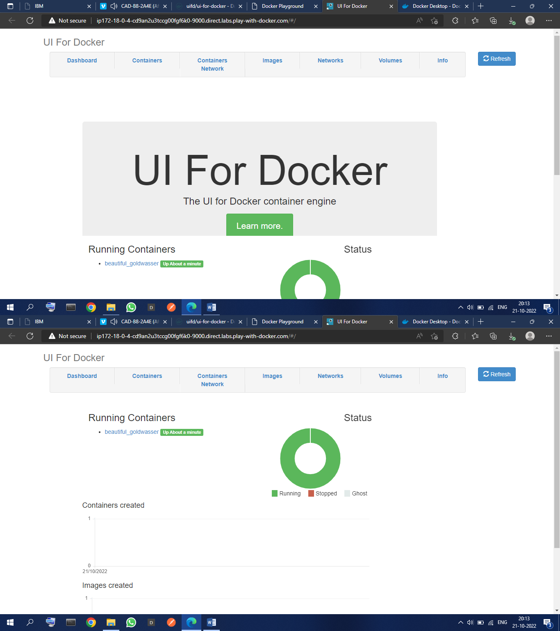**Create a docker file for the job portal application and deploy it in Docker desktop application**



1. 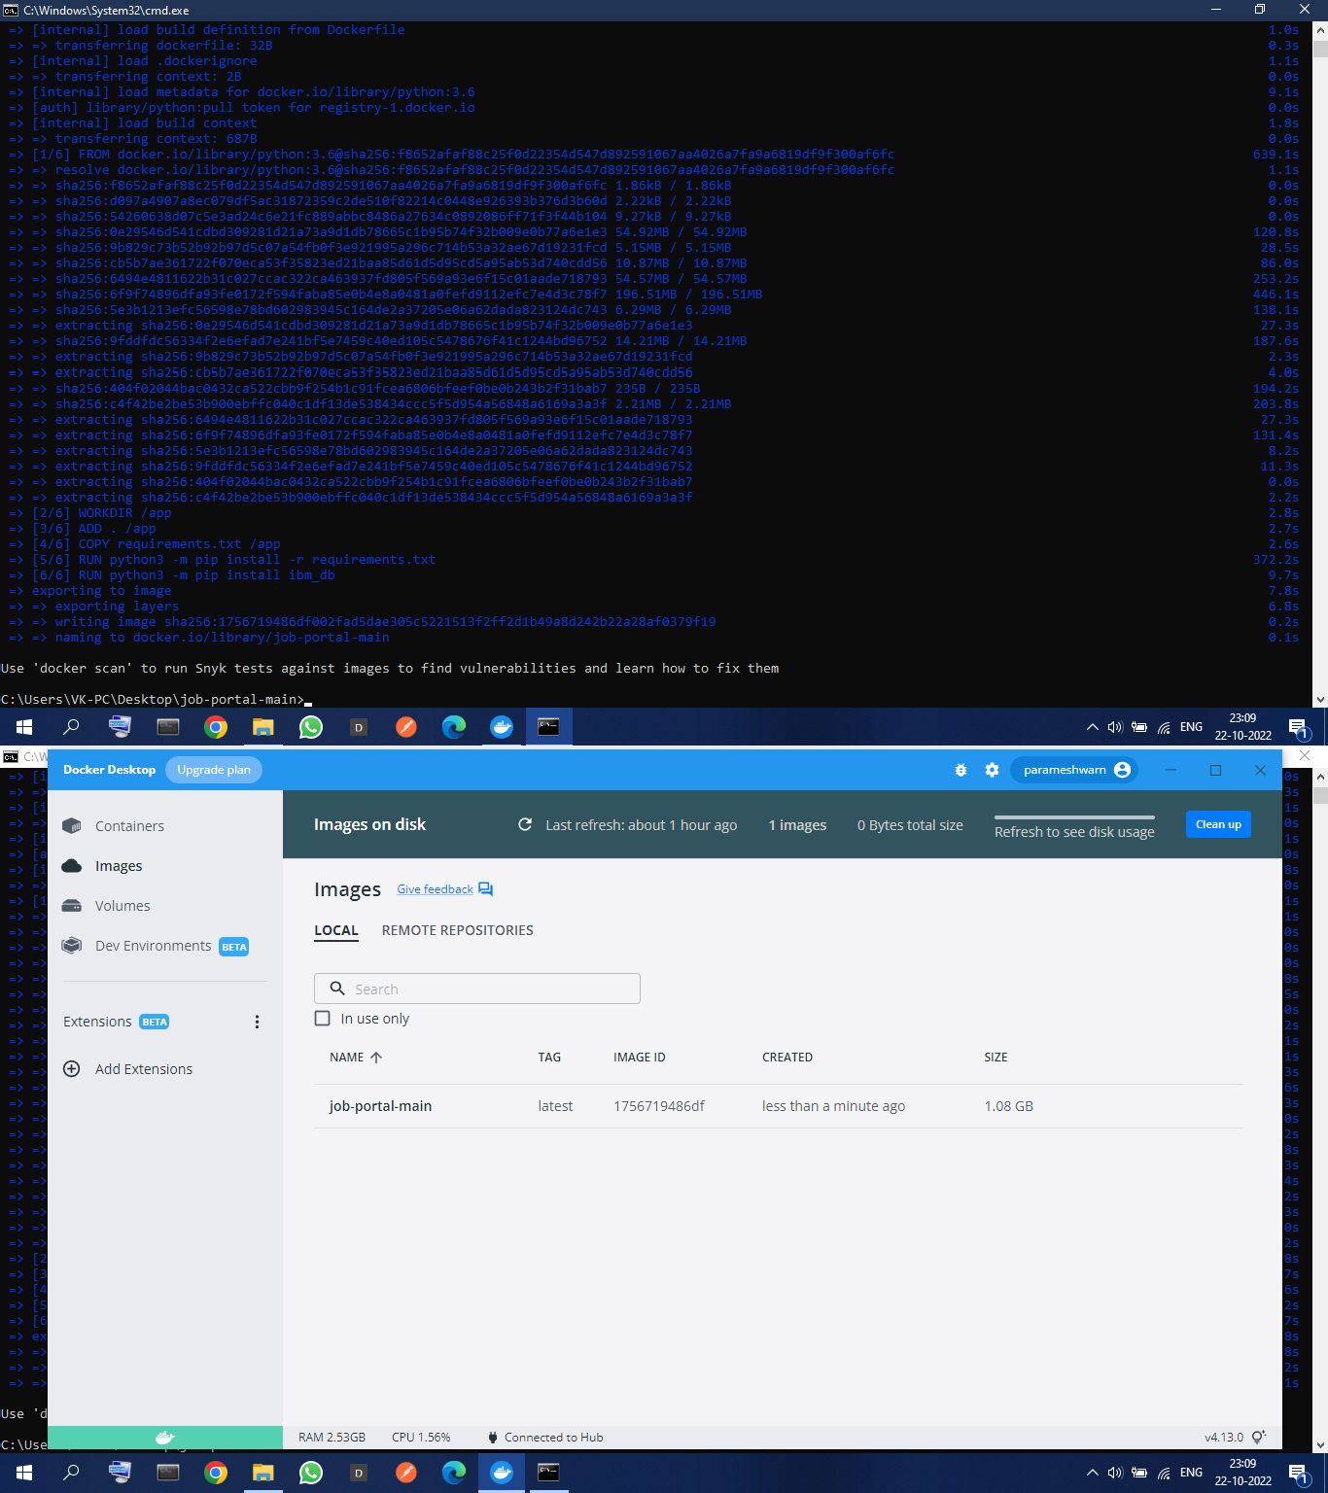**Create a Kubernetes cluster in IBM cloud and deploy helloworld image or jobportal image and also expose the same app to run in nodeport.**

